**Command.txt**

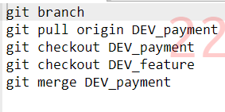

**Payment.java**

